RESUME
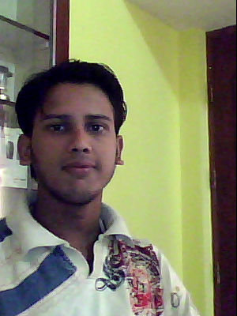
SUNNY KUMAR SINGH
Phone No:- +91-7899618661
E-Mail:- snnsingh04@gmail.com
Profile URL:- http://www.brijj.com/sunny-singh-38
Place : - Bangalore

OBJECTIVE:- To be a part of an organization that provides me opportunity to invest my knowledge and skills towards the growth of organization and long-term personal development and professional excellence.

QUALIFICATION:-
- Completed Higher Diploma in Software Engineering from NIIT.
(18 months duration)
- Pursuing Bachelor Degree (B.Sc IT) in Information Technology from Kuvempu University, Karnataka.
SESSION: 2008-2011 (2nd Cycle)
- Passed senior secondary examination with Math(I.Sc) in 2008.
- Passed secondary examination with Science in 2006.

TECHNICAL SKILL SET:-
- Programming Language : C, Core JAVA, C#
- Technologies : ASP.NET, ADO.NET
- Database Packages : SQL Server 2005
- Web Technologies : HTML, HTTP
- Concepts : OOPs, Software Engineering, Computer Network
- Operating Systems : Windows-98/ XP, Vista, 07

I worked on projects as partial fulfillment of my Course at NIIT.
- Application Developer:- December 2009 – January2010
Application for NIIT student’s data management system
Anwarpur, Hajipur (BIHAR)
Role: - Conducted regular maintenances & development in
software according to case statements.
Technology:- ADO.NET, SQL SERVER 2005, Programming using C#.

- Web Designer: - February 2009- April 2010
Website Developed for a online book store(one module)
Role: - Conducts regular maintenances on the website created.

Technology: - ASP.NET, HTML

PROFESSIONAL SKILL SET :-

- Knowledge of developing web and client/server application using .NET technologies.
- Strong emphasis knowledge of software engineering concepts and designing models.
- Knowledge of database technologies like SQL Server 2005.
- Ability to work in team as well as individual and aim for attaining overall objectivity.

PERSONALS DETAILS:-

Date of Birth : 1st March 1991
Father’s name : Mr. Shashi Bhushan Singh
Languages Known : English, Hindi
Hobbies : Volleyball, Badminton, Dancing, Clay Modeling
Marital status : Single
Sex : Male
Nationality : Indian

DECLARATION:-

I hereby declare that the above-mentioned particulars are true to the best of my knowledge and belief.

Place :- Bangalore (SUNNY KUMAR)
Date :- 11/13/2010

